

**Lab 1.1.4.6 – Configuring Basic Router Settings with IOS CLI**

## Topology

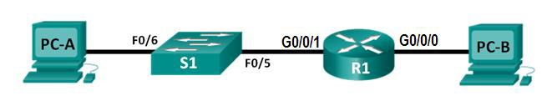

**Addressing Table**

|  |  |  |  |  |
| --- | --- | --- | --- | --- |
| **Device** | **Interface** | **IP Address** | **Subnet Mask** | **Default Gateway** |
| R1 | G0/0/0 | 192.168.0.1 | 255.255.255.0 | N/A |
|  | G0/0/1 | 192.168.1.1 | 255.255.255.0 | N/A |
| PC-A | NIC | 192.168.1.3 | 255.255.255.0 | 192.168.1.1 |
| PC-B | NIC | 192.168.0.3 | 255.255.255.0 | 192.168.0.1 |

**Objectives**

#### Part 1: Set Up the Topology and Initialize Devices

* Cable equipment to match the network topology.

#### Part 2: Configure Devices and Verify Connectivity

* Assign static IPv4 information to the PC interfaces.
* Configure basic router settings.
* Verify network connectivity.
* Configure the router for SSH.

#### Part 3: Display Router Information

* Retrieve hardware and software information from the router.
* Interpret the output from the startup configuration.
* Interpret the output from the routing table.
* Verify the status of the interfaces.

## Background / Scenario

This is a comprehensive lab to review previously covered IOS router commands. In Parts 1 and 2, you will cable the equipment and complete basic configurations and IPv4 interface settings on the router.

In Part 3, you will use SSH to connect to the router remotely and utilize IOS commands to retrieve information from the device to answer questions about the router.

For review purposes, this lab provides the commands necessary for specific router configurations.

## Required Resources

* 1 Router (Cisco 1941 with Cisco IOS Release 15.2(4)M3 universal image or comparable)
* 1 Switch (Cisco 2960 with Cisco IOS Release 15.0(2) lanbasek9 image or comparable)
* 2 PCs (Windows 7, Vista, or XP with terminal emulation program, such as Tera Term)
* Ethernet cables as shown in the topology

**Note**: The Gigabit Ethernet interfaces on Cisco 1941 ISRs are autosensing and an Ethernet straight-through cable can be used between the router and PC-B. If using another model Cisco router, it may be necessary to use an Ethernet crossover cable.

# Part 1: Set Up the Topology and Initialize Devices

### Step 1: Cable the network as shown in the topology.

1. Attach the devices as shown in the topology diagram, and cable as necessary.
2. Power on all the devices in the topology.

# Part 2: Configure Devices and Verify Connectivity

### Step 1: Configure the PC interfaces.

1. Configure the IP address, subnet mask, and default gateway settings on PC-A.
2. Configure the IP address, subnet mask, and default gateway settings on PC-B.
   * + Click the **Windows Start** icon and then select **Control Panel**.
     + In the **Network and Internet** section, click the **View network status and tasks** link. **Note**: If the Control Panel displays a list of icons, click the drop-down option next to the **View by**: and change this option to display by **Category**.

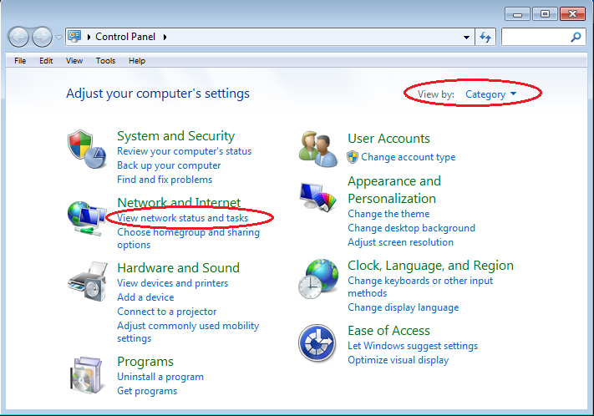

* + - In the left pane of the **Network and Sharing Center** window, click the **Change adapter settings** link.

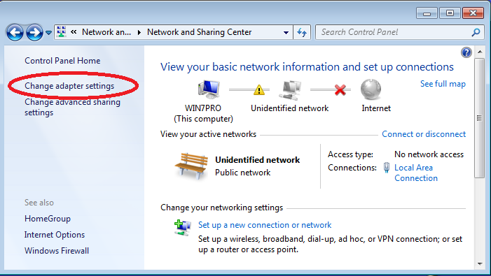

* + The Network Connections window displays the available interfaces on the PC. Right-click the **Local Area Connection** interface and select **Properties**.

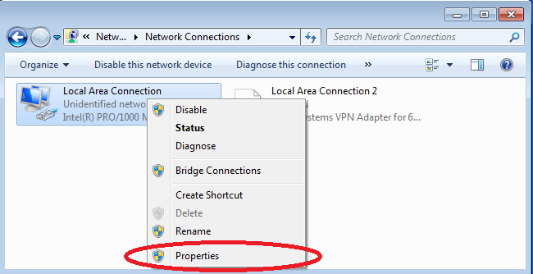

* Select the **Internet Protocol Version 4 (TCP/IPv4)** option and then click **Properties**.

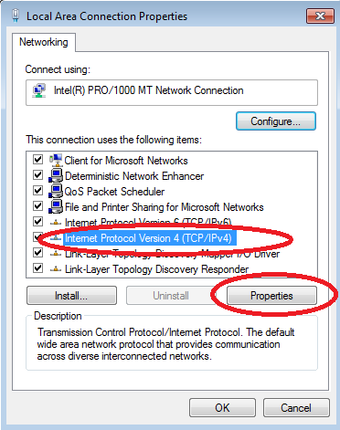

**Note**: You can also double-click **Internet Protocol Version 4 (TCP/IPv4**) to display the Properties window.

* Click the **Use the following IP address** radio button to manually enter an IP address, subnet mask, and default gateway.

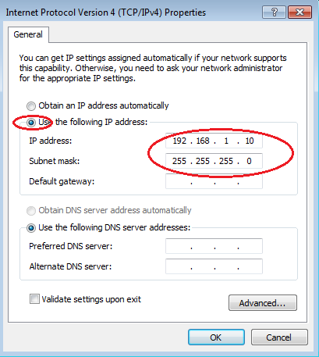

### Step 2: Establish a console session with the router.

**Tera Term** is a terminal emulation program. This program allows you to access the terminal output of the switch. It also allows you to configure the switch.

1. Start **Tera Term** by clicking the **Windows Start** button located in the task bar. Locate **Tera Term** under **All Programs**.
2. In the New Connection dialog box, click the **Serial** radio button. Verify that the correct COM port is selected and click **OK** to continue.

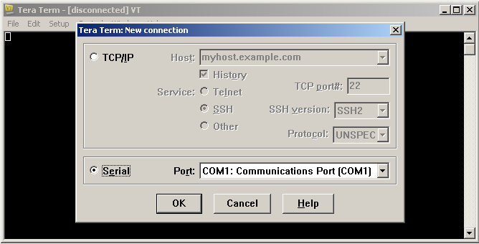

1. From the **Tera Term** **Setup** menu, choose the **Serial port**… to verify the serial settings. The default parameters for the console port are **9600 baud**, **8 data bits**, **no parity**, **1 stop bit**, and **no flow control**. The **Tera Term** default settings match the console port settings for communications with the Cisco IOS switch.

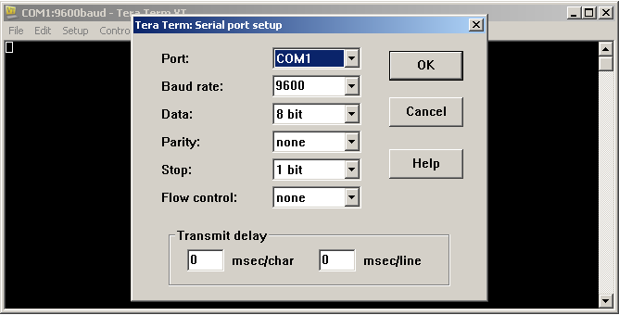

* + 1. When you can see the terminal output, you are ready to configure a Cisco router. The following console example displays the terminal output of the switch while it is loading.

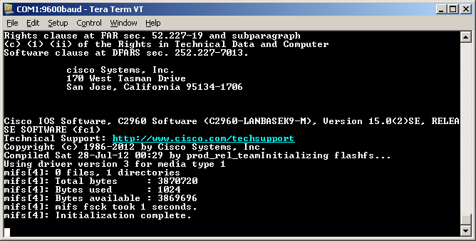

* + 1. After the router has completed its startup process, the following message is displayed. Enter **n** to continue**.**

**Would you like to enter the initial configuration dialog? [yes/no]: n**

**Note**: If you do not see the above message, please contact your instructor to reset your router to the initial configuration.

### Step 3: Configure the router.

a. Console into the router and enable privileged EXEC mode.

Router> **enable**

Router#

1. Enter into global configuration mode.

Router# **config t**

Enter configuration commands, one per line. End with CNTL/Z.

Router(config)#

c. Assign a device name to the router.

Router(config)# **hostname R1**

1. Disable DNS lookup to prevent the router from attempting to translate incorrectly entered commands as though they were hostnames.

R1(config)# **no ip domain-lookup**

e. Require that a minimum of 10 characters be used for all passwords.

R1(config)# **security passwords min-length 10**

Besides setting a minimum length, list other ways to strengthen passwords.

f. Assign **cisco12345** as the privileged EXEC encrypted password.

R1(config)# **enable secret cisco12345**

* + - Assign **ciscoconpass** as the console password, establish a timeout, enable login, and add the **logging synchronous** command. The **logging synchronous** command synchronizes debug and Cisco IOS software output and prevents these messages from interrupting your keyboard input.

R1(config)# **line con 0**

R1(config-line)# **password ciscoconpass**

R1(config-line)# **exec-timeout 5 0**

R1(config-line)# **login**

R1(config-line)# **logging synchronous**

R1(config-line)# **exit**

R1(config)#

For the **exec-timeout** command, what do the **5** and **0** represent?

____________________________________________________________________________________

* + - Assign **ciscovtypass** as the vty password, establish a timeout, enable login, and add the **logging synchronous** command.

R1(config)# **line vty 0 4**

R1(config-line)# **password ciscovtypass**

R1(config-line)# **exec-timeout 5 0**

R1(config-line)# **transport input telnet**

R1(config-line)# **login**

R1(config-line)# **logging synchronous**

R1(config-line)# **exit**

R1(config)#

i. Encrypt the clear text passwords.

R1(config)# **service password-encryption**

j. Create a banner that warns anyone accessing the device that unauthorized access is prohibited.

R1(config)# **banner motd #Unauthorized access prohibited!#**

k. Configure an IP address and interface description. Activate both interfaces on the router.

R1(config)# **int g0/0**

R1(config-if)# **description Connection to PC-B**

R1(config-if)# **ip address 192.168.0.1 255.255.255.0**

R1(config-if)# **no shutdown**

R1(config-if)# **int g0/1**

R1(config-if)# **description Connection to S1**

R1(config-if)# **ip address 192.168.1.1 255.255.255.0**

R1(config-if)# **no shutdown**

R1(config-if)# **exit**

R1(config)# **exit**

R1#

* + - Set the clock on the router; for example:

R1# **clock set 17:00:00 18 Aug 2021**

**Step 4: Verify network connectivity.**

1. Ping **PC-B** from a command prompt on **PC-A**.

Were the pings successful? ____

After completing this series of commands, what type of remote access could be used to access R1?

____________________________________________________________________________________

* + - Remotely access R1 from PC-A using the Telnet.

On the command line of PC-A insert the following command: **telnet 192.168.1.1** with

password **ciscovtypass**

Was remote access successful? ____

Why is the Telnet protocol considered to be a security risk?

____________________________________________________________________________________

**Step 4: Configure the router for SSH access.**

a. Enable SSH connections and create a user in the local database of the router.

R1# **configure terminal**

R1(config)# **ip domain-name CCNA-lab.com**

R1(config)# **username admin privilege 15 secret adminpass1**

R1(config)# **line vty 0 4**

R1(config-line)# **transport input ssh**

R1(config-line)# **login local**

R1(config-line)# **exit**

R1(config)# **crypto key generate rsa**

**Type the value of 1024 as the answer to the question and press enter.**

R1(config)# **exit**

* + - Remotely access **R1** from **PC-A** using the **SSH**.

On the command line of **PC-A** insert the following command: **ssh –l admin 192.168.1.1** with the password **adminpass1**.

Was remote access successful? ____

* + - Start **Teraterm** from **PC-A**.
    - Establish an **SSH** session to **R1**.

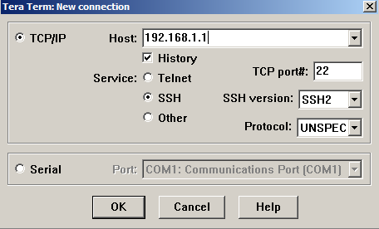

**NOTA:** La primera vez que establece una sesión de SSH con un dispositivo, se genera una **SECURITY WARNING** (ADVERTENCIA DE SEGURIDAD) para comunicarle que no se conectó a ese dispositivo anteriormente. Este mensaje es parte del proceso de autenticación. Lea la advertencia de seguridad y, luego, haga clic en **Continue** (Continuar).

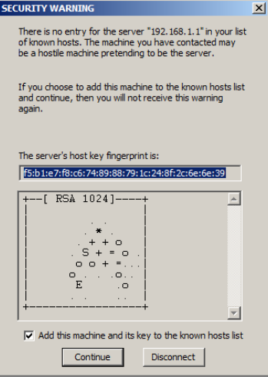

1. Use the username admin and password adminpass1. You should be able to establish an SSH session with R1.

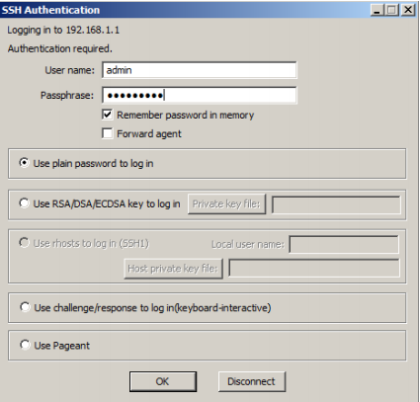

# Part 3: Display Router Information

In Part 3, you will use **show** commands from an SSH session to retrieve information from the router.

### Step 1: Establish an SSH session to R1.

**Step 2: Retrieve important hardware and software information.**

1. Use the **show version** command to answer questions about the router.

R1# **show version**

Cisco IOS Software, C1900 Software (C1900-UNIVERSALK9-M), Version 15.2(4)M3, RELEASE SOFTWARE (fc1)

Technical Support: http://www.cisco.com/techsupport

Copyright (c) 1986-2012 by Cisco Systems, Inc.

Compiled Thu 26-Jul-12 19:34 by prod_rel_team

ROM: System Bootstrap, Version 15.0(1r)M15, RELEASE SOFTWARE (fc1)

R1 uptime is 10 minutes

System returned to ROM by power-on

System image file is "**flash0:c1900-universalk9-mz.SPA.152-4.M3.bin"**

Last reload type: Normal Reload

Last reload reason: power-on

This product contains cryptographic features and is subject to United

States and local country laws governing import, export, transfer and

use. Delivery of Cisco cryptographic products does not imply

third-party authority to import, export, distribute or use encryption.

Importers, exporters, distributors and users are responsible for

compliance with U.S. and local country laws. By using this product you

agree to comply with applicable laws and regulations. If you are unable

to comply with U.S. and local laws, return this product immediately.

A summary of U.S. laws governing Cisco cryptographic products may be found at:

http://www.cisco.com/wwl/export/crypto/tool/stqrg.html

If you require further assistance please contact us by sending email to

export@cisco.com.

Cisco CISCO1941/K9 (revision 1.0) with 446464K/77824K bytes of memory.

Processor board ID FTX1636848Z

2 Gigabit Ethernet interfaces

2 Serial(sync/async) interfaces

1 terminal line

DRAM configuration is 64 bits wide with parity disabled.

**255K bytes of non-volatile configuration memory.**

**250880K bytes of ATA System CompactFlash 0 (Read/Write)**

-----------------------------------------------------------------

Technology Technology-package Technology-package

Current Type Next reboot

------------------------------------------------------------------

ipbase ipbasek9 Permanent ipbasek9

security None None None

data None None None

**Configuration register is 0x2142 (will be 0x2102 at next reload)**

What is the name of the IOS image that the router is running?

How much non-volatile random-access memory (NVRAM) does the router have?

How much Flash memory does the router have?

1. The **show** commands often provide multiple screens of outputs. Filtering the output allows a user to display certain sections of the output. To enable the filtering command, enter a pipe (**|**) character after a **show** command, followed by a filtering parameter and a filtering expression. You can match the output to the filtering statement by using the **include** keyword to display all lines from the output that contain the filtering expression. Filter the **show version** command, using **show version | include register** to answer the following question.

What is the boot process for the router on the next reload?

In most cases (**0x2102**), the router will undergo a normal boot, load the IOS from the Flash memory, and load the startup configuration from the NVRAM if present. If the config register is **0x2142**, the router will bypass the startup config and begin at the user-mode command prompt. If the initial boot fails, the router goes into ROMMON mode.

### Step 3: Display the startup configuration.

Use the **show running-config** command on the router to answer the following questions.

How are passwords presented in the output?

Use the **show running-config | begin vty** command. What is the result of using this command?

### Step 4: Display the routing table on the router.

Use the **show ip route** command on the router to answer the following questions.

What code is used in the routing table to indicate a directly connected network?

How many route entries are coded with a C code in the routing table?

### Step 5: Display a summary list of the interfaces on the router.

Use the **show ip interface brief** command on the router to answer the following question.

What command changed the status of the Gigabit Ethernet ports from administratively down to up?

**Reflection**

1. In researching a network connectivity issue, a technician suspects that an interface was not enabled. What

**show** command could the technician use to troubleshoot this issue?

1. In researching a network connectivity issue, a technician suspects that an interface was assigned an incorrect subnet mask. What **show** command could the technician use to troubleshoot this issue?